Face Lock

In this project you will make a Scratch project that can unlock a virtual phone using your face.

You’ll train a machine learning model to be able to recognise a face so that it only unlocks the phone for the right person.

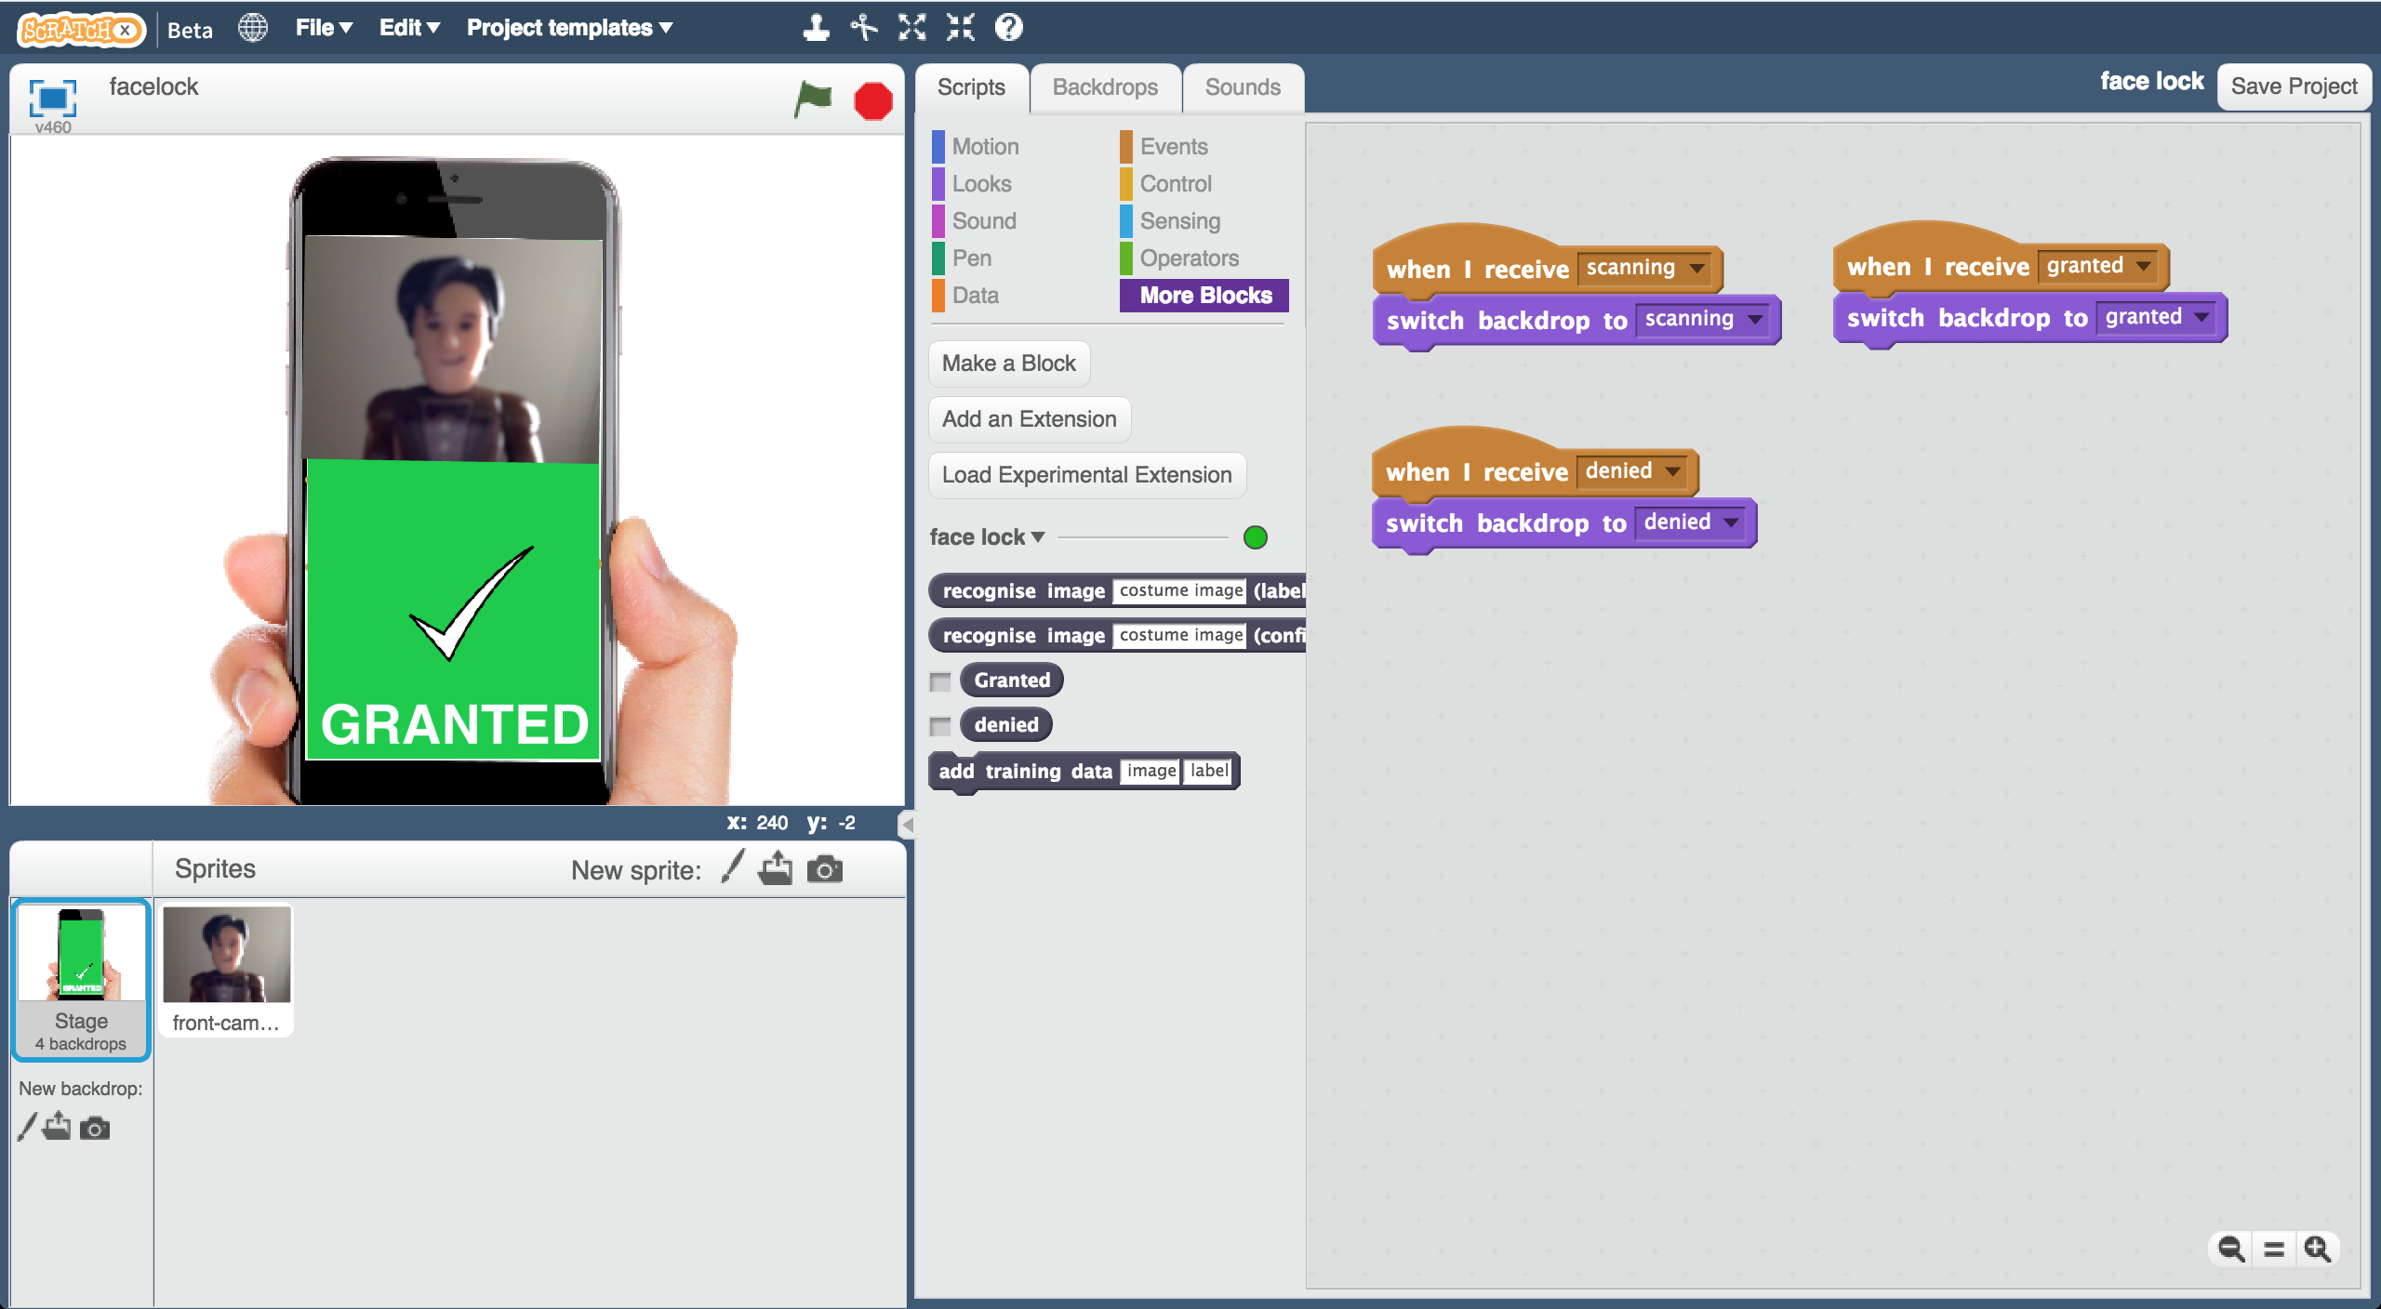

Creative Commons LicenceThis project worksheet is licensed under a Creative Commons Attribution Non-Commercial Share-Alike License

http://creativecommons.org/licenses/by-nc-sa/4.0/

This worksheet was contributed by Jasmine Crisp and Daniel May, from Mountbatten School.

1. Go to <https://machinelearningforkids.co.uk/> in a web browser

1. Click on “**Get started**”

1. Click on “**Log In**” and type in your username and password  
   *If you don’t have a username, ask your teacher or group leader to create one for you.  
   If you can’t remember your username or password, ask your teacher or group leader to reset it for you.*

1. Click on “**Projects**” on the top menu bar

1. Click on the **“+ Add a new project**” button.
2. Name your project “face lock” and set it to learn how to recognise “**images**”  
   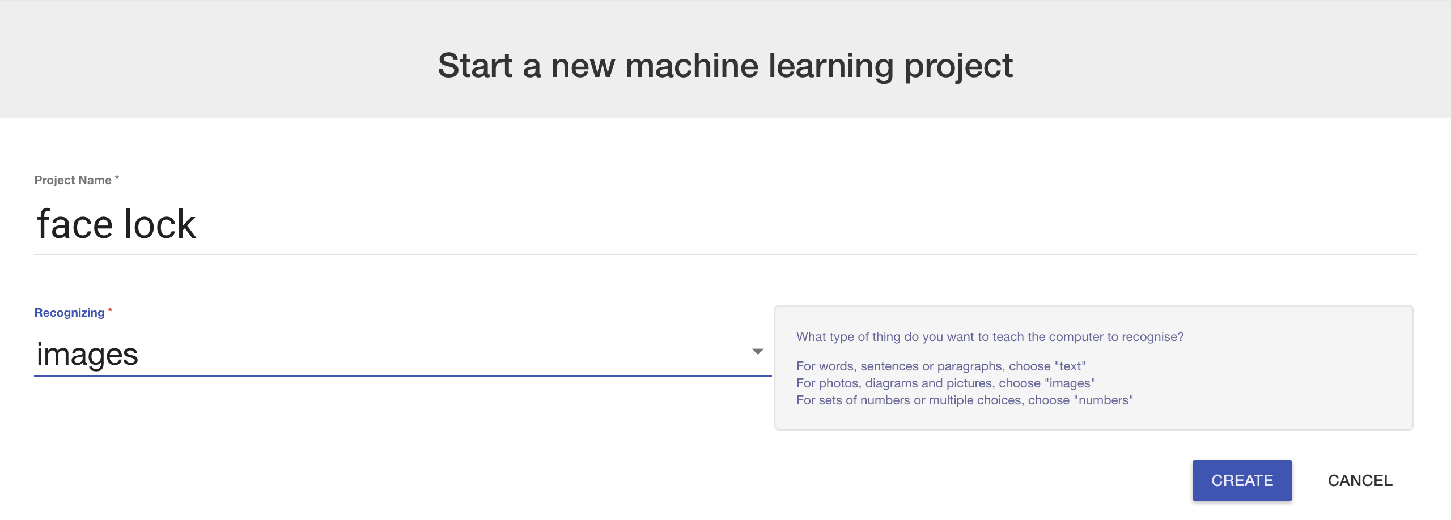
3. You should see “face lock” in your list of projects. Click on it.
4. Click the “**Train**” button to start collecting examples  
   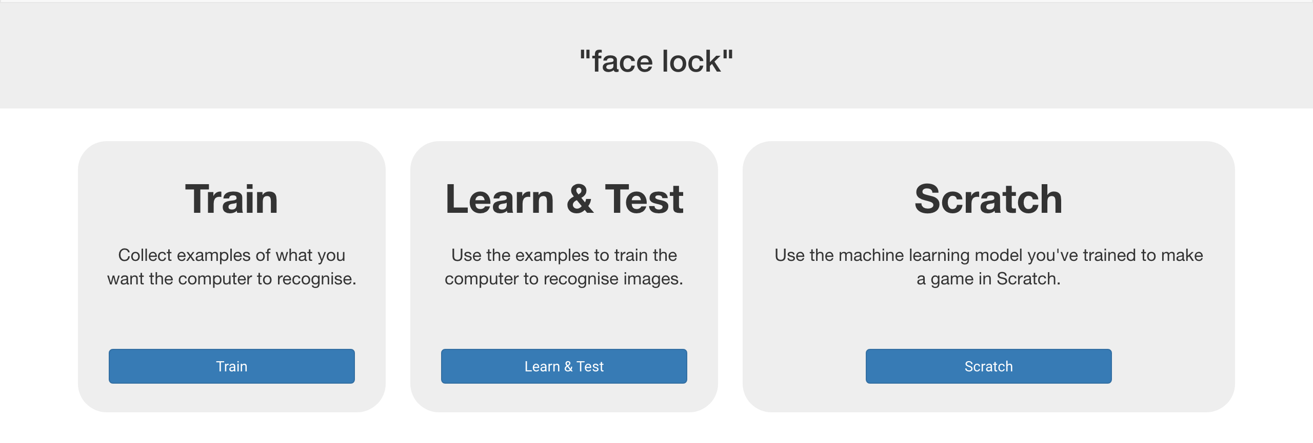
5. Click on “**+ Add new label**”. Create a bucket called “Granted”  
   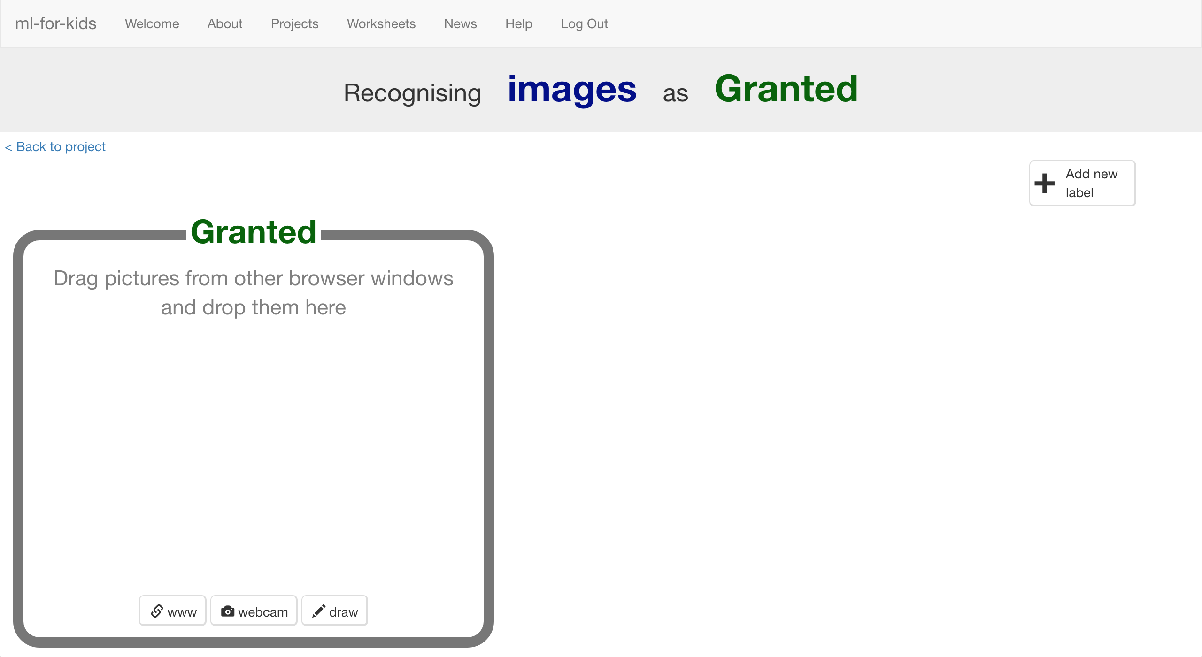
6. Click “**webcam**”.   
   A preview window will show the current view from your webcam.  
   *You will need to click “Approve” or “Allow” if your web browser asks permission to use your webcam.*
7. Put your face in front of the webcam, and click “**Add**” to take a picture of it.   
   *Make sure you have permission to upload photos of your face. If you don’t, use a toy with a face like we’ve done here.*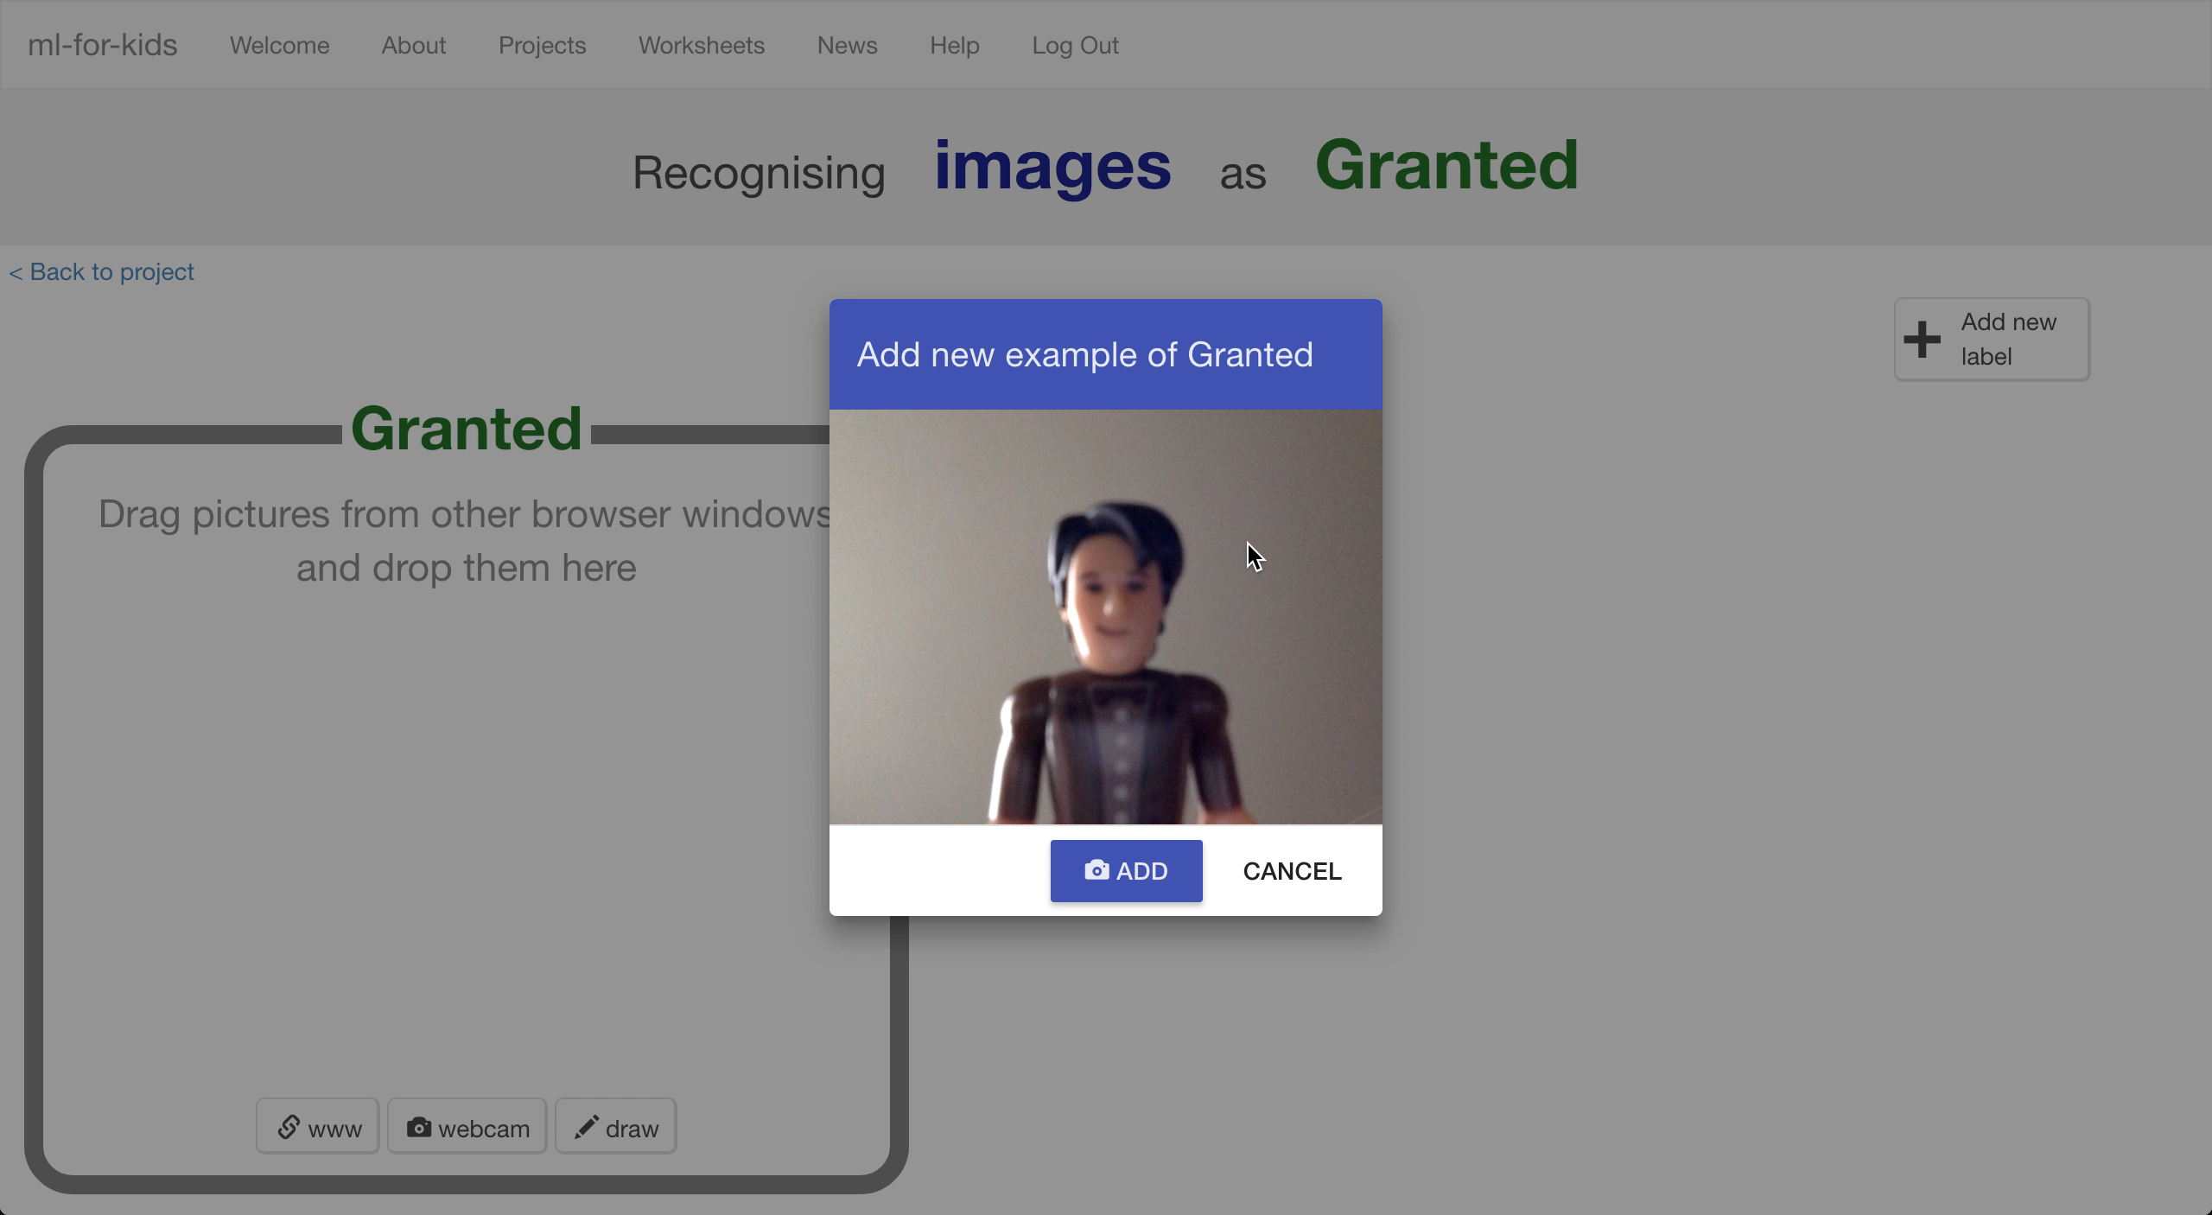
8. Repeat until you’ve got at least 10 examples of your face.   
   *Try to get pictures with different backgrounds, angles, focuses, and distances from the webcam.   
   The more variation the computer has to learn from, the better.*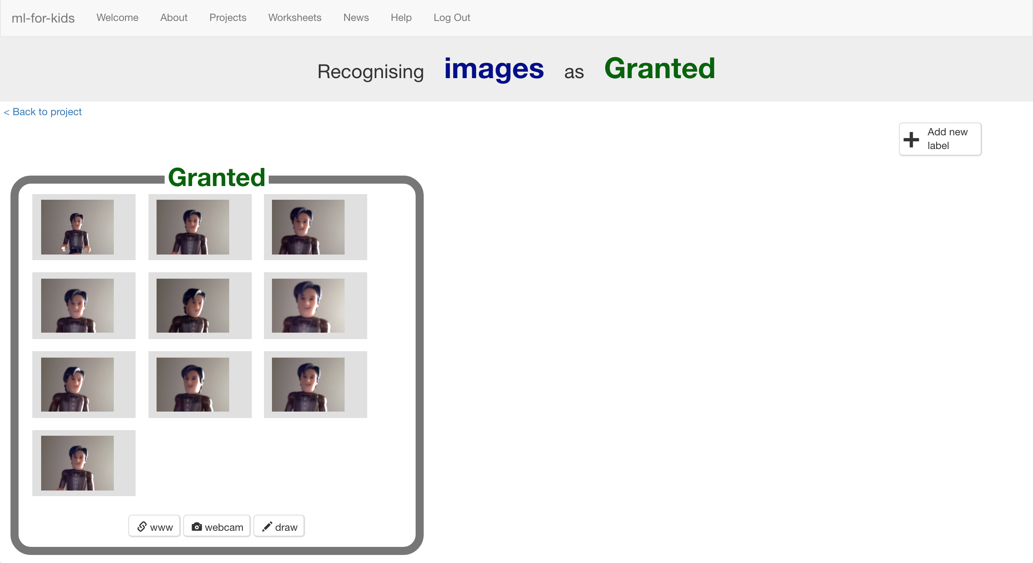
9. Click “**+ Add new label**” and create one called “denied”
10. Use the “**webcam**” button in the “denied” bucket to take 10 photos of other people’s faces  
    *Try to vary these pictures in the same way that you varied your first set.*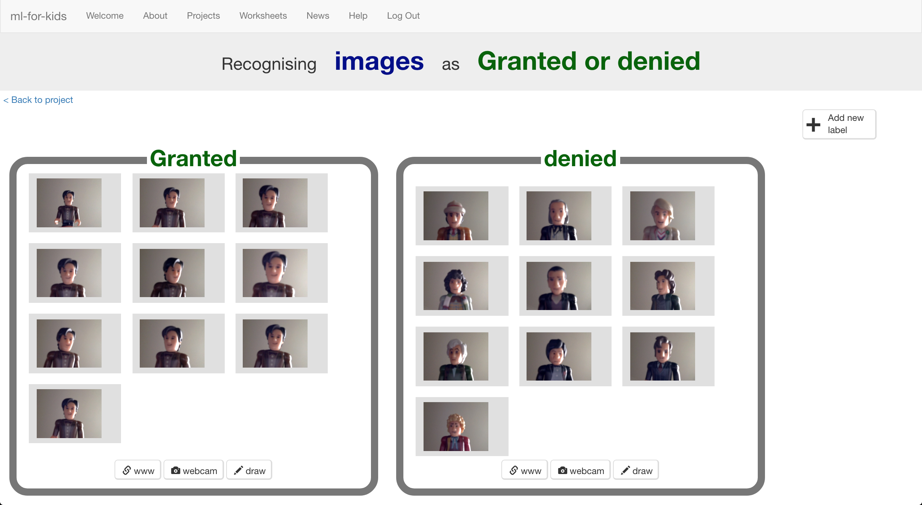
11. Click on the “**< Back to project**” link
12. Click the “**Learn & Test**” button
13. Click the “**Train new machine learning model**” button  
    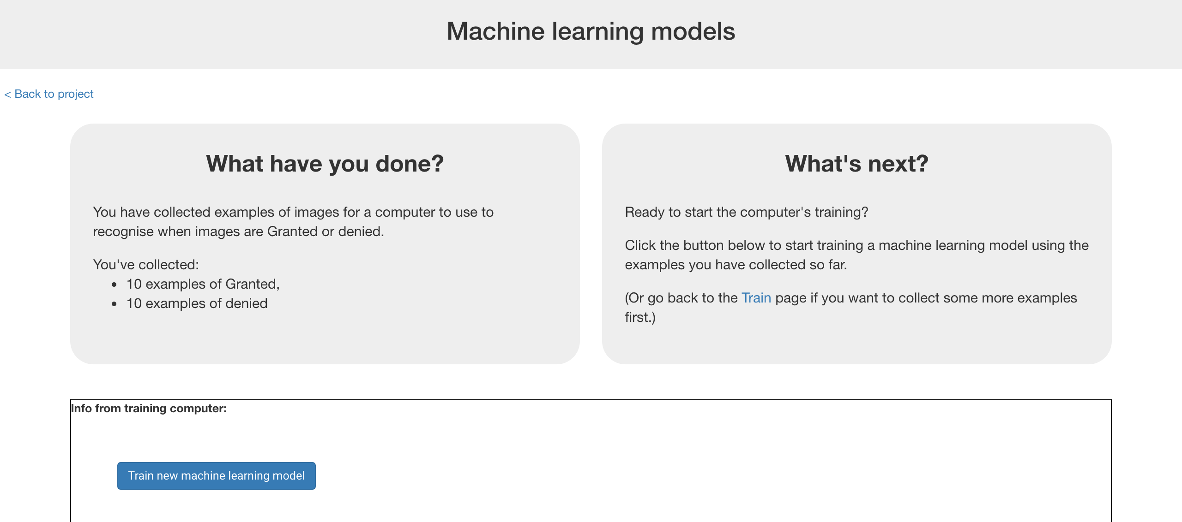
14. Wait for the training to complete.   
    *This might take a few minutes. You’ll know when it’s done when it gives you the opportunity to test the model. Why not try doing the quiz?*

**What have you done so far?**

You’re started to train a computer to recognise pictures of you.

Instead of trying to write rules to be able to do this, you are doing it by collecting pictures of yourself. These examples are being used to train a machine learning “model”.

This is called “supervised learning” because of the way that you are supervising the computer’s training.

The computer will learn from the patterns in the photos you’ve taken. Hopefully this will mostly be the facial features and hair, but beware that it might also include the clothes and background!

1. In the training page, click the **“< Back to project**” link.   
   Then click the **Scratch** button.
2. Click the **Open in Scratch** button.  
   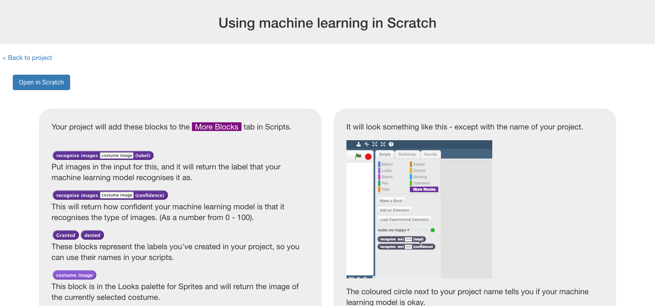
3. Load the Face Lock template project  
   *Click* ***Project templates*** *->* ***Face Lock*** *as shown below*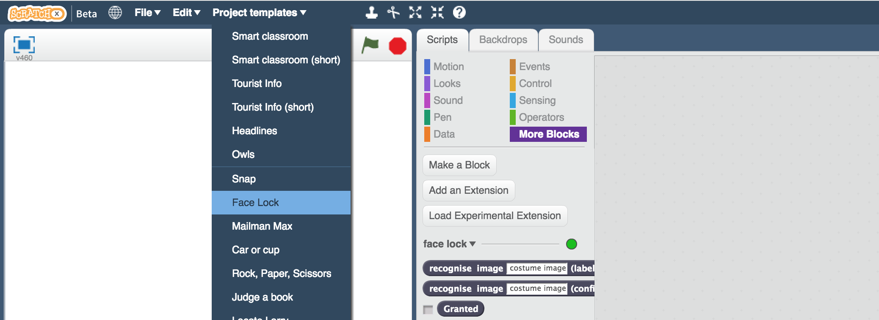
4. Create this script  
   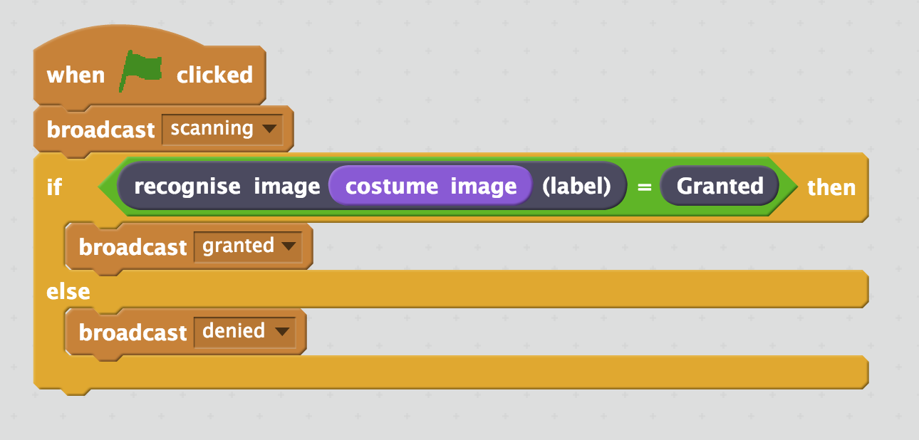
5. Click on the “**Costumes**” tab,   
   then click on the “**New costume from camera**” button  
   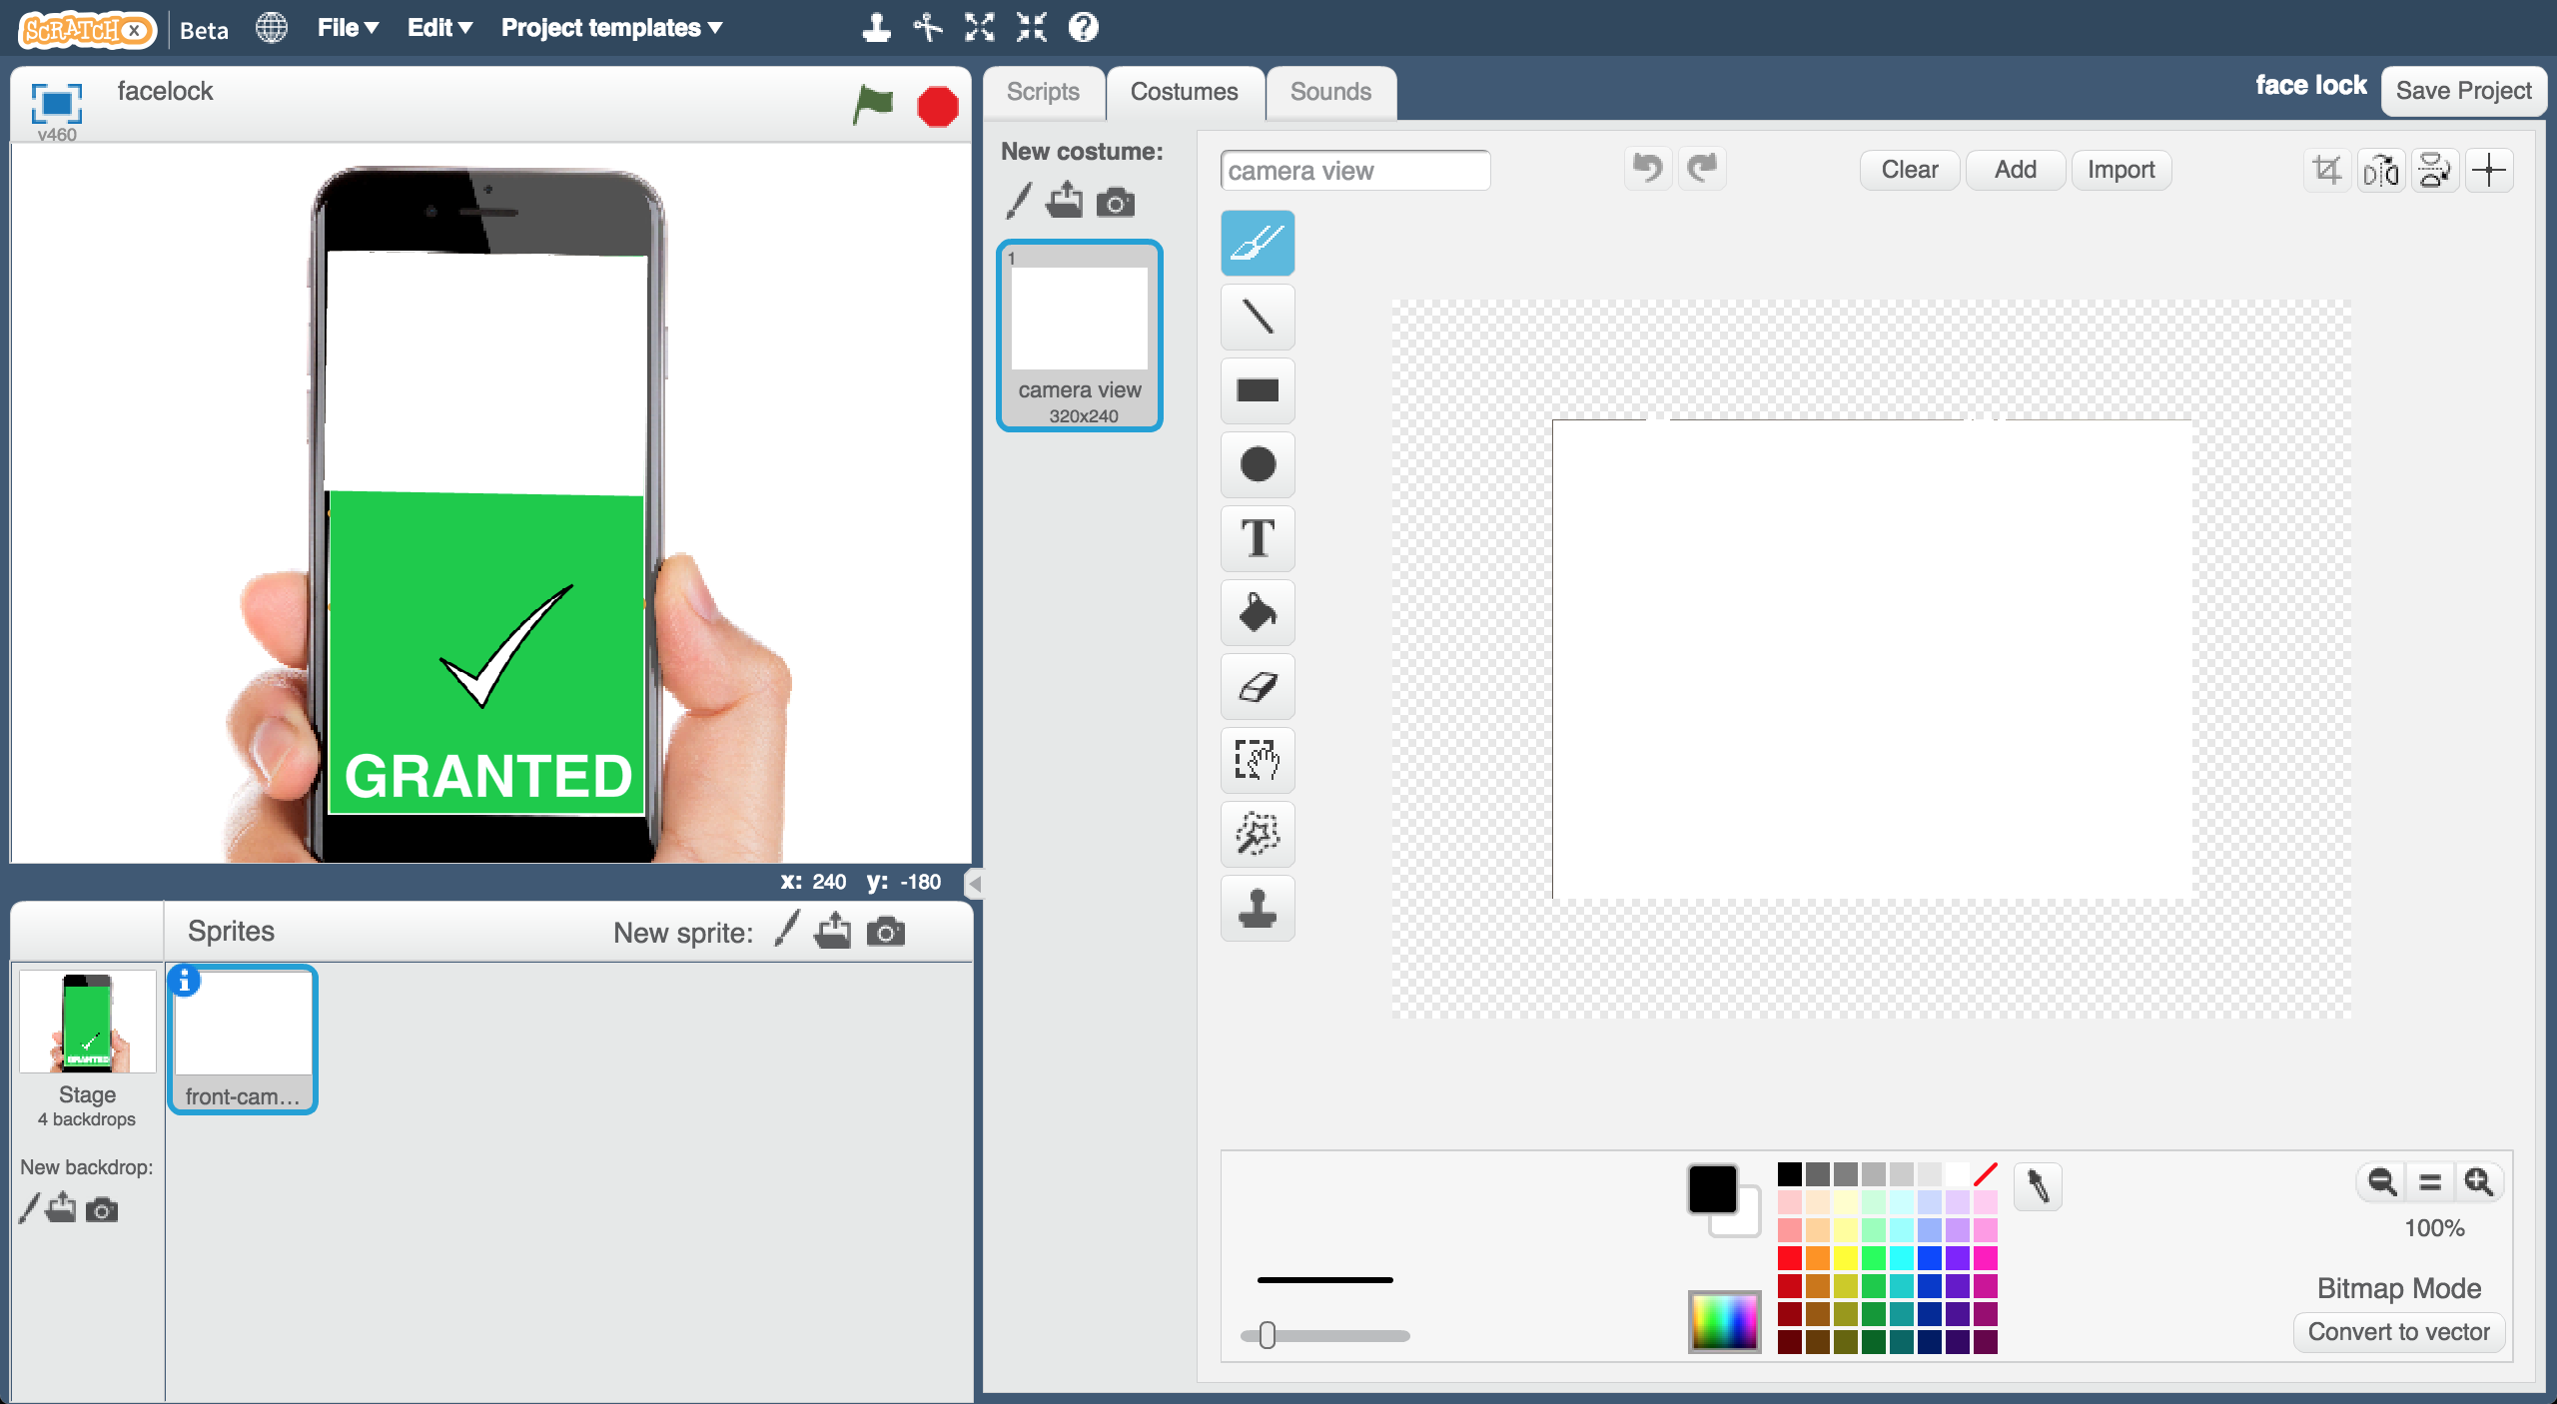
6. Use the webcam to take a photo of a face that should not be allowed to use the phone  
   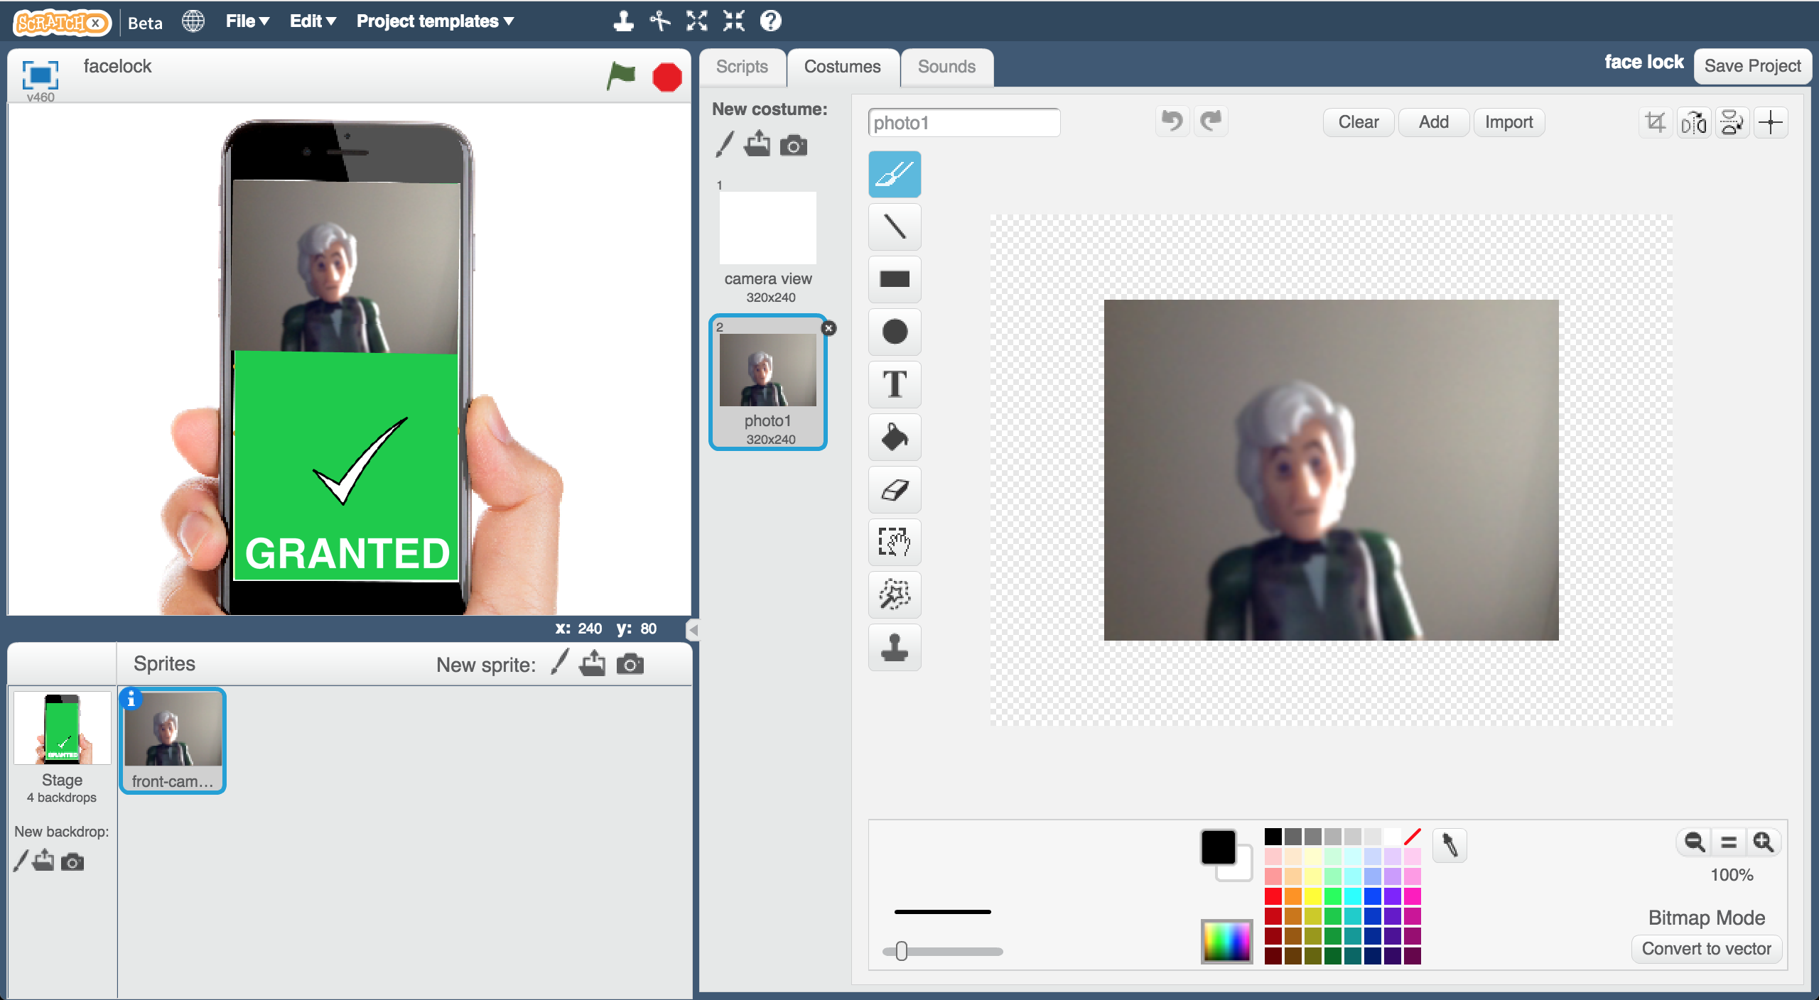
7. Click the “**New costume from camera**” button again, and take a photo of a face that should be allowed to use the phone   
   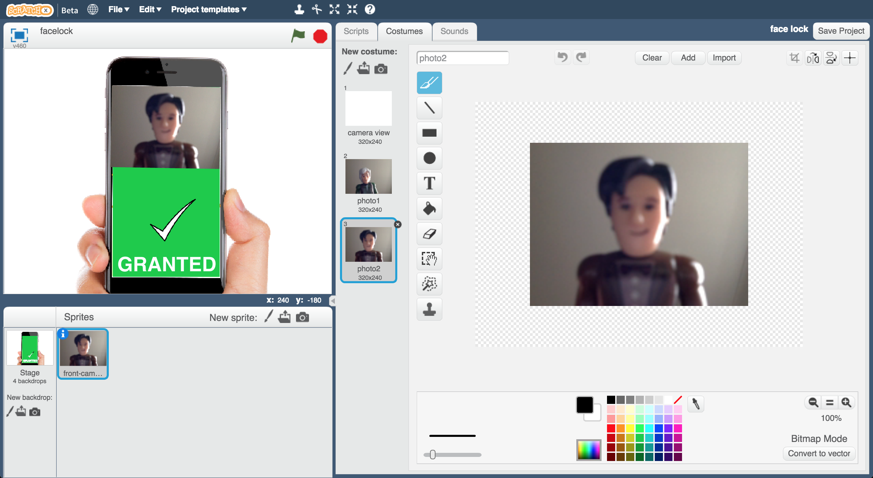
8. Click on the **Stage**   
   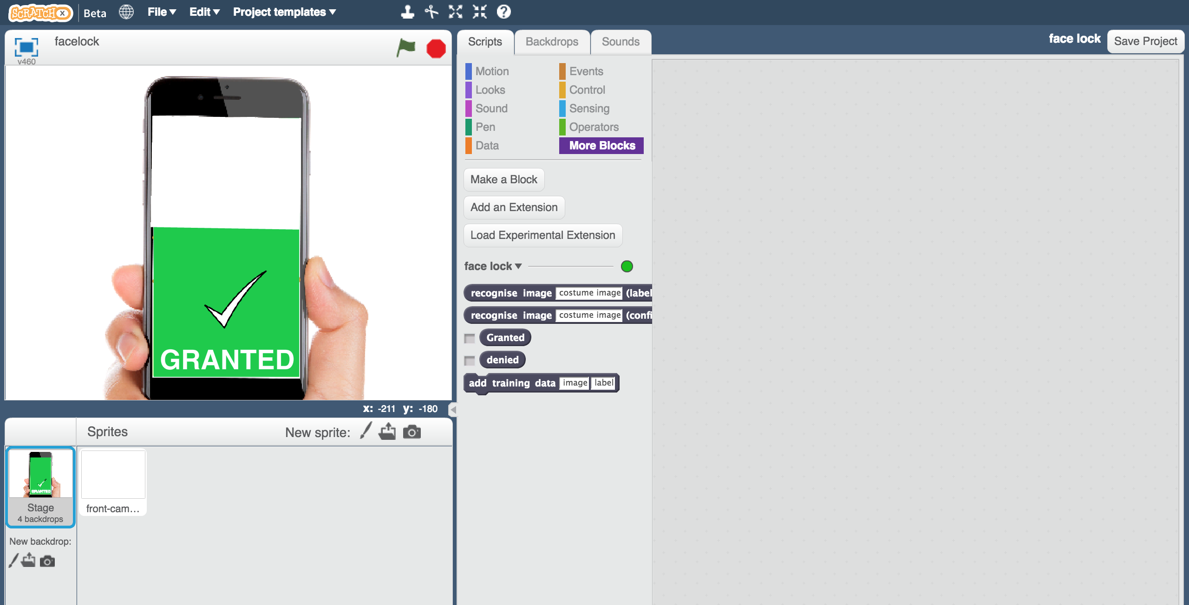
9. Create the following scripts  
   *These will make the phone screen update based on whether it is locked.*  
   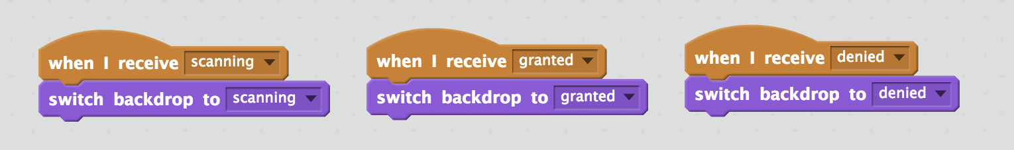
10. It’s time to test! Click the green flag  
    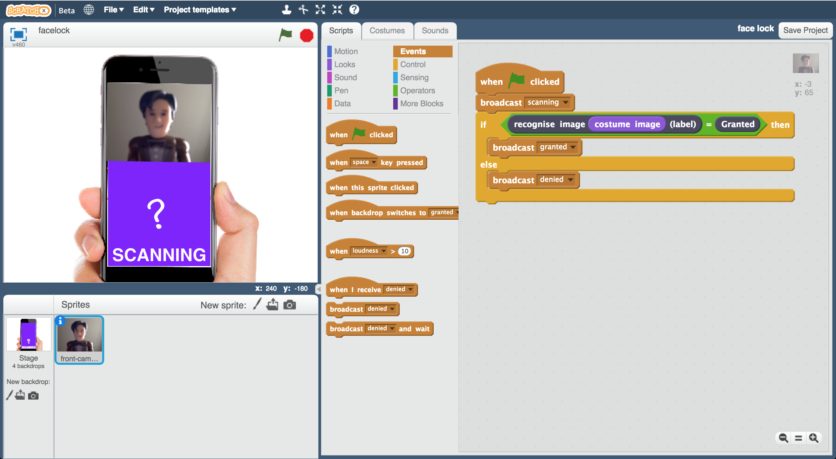

**Ideas and Extensions**

**What if the computer isn’t sure?**

The confidence block returns a percentage (a number from 0 to 100) with how confident it is that it has recognised the face.

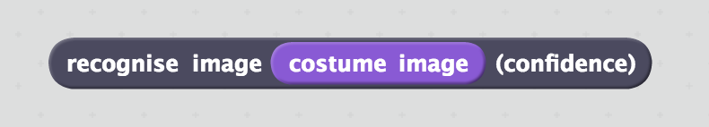

How could you update your script to use this?

Should the phone still unlock if the computer is only 10% sure that it has correctly recognised the owner’s face?

**Add more people for the computer to accept**

Can you get the phone to recognise two different people’s faces that it should let through?

**Try confusing the computer**

If you train the computer to recognise you while you’re in one place only, can it still recognise you if you are somewhere else? What if you change your clothes?

Is the computer recognising your face, or something else?

Experiment to find out how the computer learns and how it behaves.

**What have you done?**

You’ve trained a facial recognition system. You’ve done this by collecting examples of pictures of faces, and used this to train a machine learning model that is able to recognise faces.

You’ve used this model to create an app, using the model as an authentication method (a way of proving that someone is who they say they are).

It’s a very simple system so far.

Can you think of ways that you could fool it?

**Did you know?**

The first known attempt at facial recognition was in 1965 by Woodrow Wilson Bledsoe. He manually inputted measurements of a person’s face and stored them, along with measurements of other people’s faces.

When presented with a new photograph, the system could be used to work out which person most closely resembled the picture.

He found a number of issues with getting his system to cope with differences in “head rotation, tilt, light intensity, the angle of the light, aging, facial expression” and a number of other factors. These were impossible to avoid at the time.

Recently, Apple introduced facial recognition into their phones, by using software known as Face ID. Instead of relying on pictures, this makes a detailed map of over 30,000 specific points on your face. This helps it to handle small changes in the look of your face, such as wearing makeup or a different hairstyle. Other companies, such as Samsung, have also introduced similar technology to their phones.